Project Report on

Project Title

*Submission to The Robotics Club – SNIST as a part of Induction’24*

Team No –

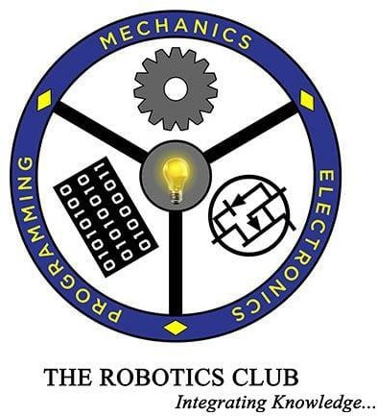

THE ROBOTICS CLUB – SNIST

SREENIDHI INSTITUTE OF SCIENCE AND TECHNOLOGY

(AUTONOMOUS)

(Affiliated to JNTU University, Hyderabad)

Yamnampet, Ghatkesar, Hyderabad – 501301

2023

**CERTIFICATE**

This is the project work titled ‘project_title’ by ‘team_member_names’, under the mentorship of ‘mentor name’ and ‘mentor name’, and is a record of the project work carried out by them during the year 2023-24 as a part of INDUCTION’24 under the guidance and supervision of

**Mr. G. Kovidh Addhish**

**&**

**Mr. Aarushraj Puduchery**

**Technical Heads**

**Mr. N V V S Narayana**

**The President of**

**The Robotics Club**

**Dr. A. PURUSHOTHAM**

**Faculty Advisor**

**DECLARATION**

The project work reported in the present thesis titled “**project name**” is a record of work done by Team team_number in **THE ROBOTICS CLUB** as a part of **INDUCTION’24.**

**No part of the thesis is copied from books/journals/Internet and wherever the portion is taken, the same has been duly referred in the text. The report is based on the project work done entirely by Team team_number and not copied from any other source.**

**ACKNOWLEDGEMENT**

This project report is the outcome of the efforts of many people who have driven our passion to explore into the implementation of **SANITRON** . We have received great guidance, encouragement and support from them and have learned a lot because of their willingness to share their knowledge and experience.

We thank our technical heads **Mr. G. Kovidh Addhish and Mr. Aarushraj Puduchery** for being with us till the end of the project completion.

We thank all members of the **Steering Body, Executive Body, Technical Advisory Board and Club’s Incubation and Competence Committee** of **The Robotics Club** for helping us with crucial parts of the project. We are deeply indebted to **Mr. N V V S Narayana** – The President, **Ms. Mugala Shravani** – The Vice President, **Mr. N Abinav** – General Secretary and **Ms. Maliha** – SAB Chairman **THE ROBOTICS CLUB** respectively and also every other person who spared their valuable time without any hesitation whenever we wanted.

We also thank our faculty advisor **Dr. A. Purushotham**, Professor Mechanical Department, who encouraged us during this project by rendering his help when needed.

Contents : pgNo :

|  |  |  |
| --- | --- | --- |
| Chapter 1 | Introduction |  |
| 1.1 | Problem St  Atement |  |
| 1.2 | Introduction |  |
| 1.3 | Literature Survey |  |

|  |  |  |
| --- | --- | --- |
| Chapter 2 | Architecture |  |
| 2.1 | List of Figures |  |
| 2.2 | Components Used |  |
| 2.3 | Hardware |  |
| 2.4 | Software |  |

|  |  |  |
| --- | --- | --- |
| Chapter 3 | Implementation and Working |  |
| 3.1 | Block diagram |  |
| 3.2 | Circuit diagram |  |
| 3.3 | Working |  |
| 3.4 | Flowchart |  |

|  |  |  |
| --- | --- | --- |
| Chapter4 | Experimental Results and Conclusions: |  |
| 4.1 | Results |  |
| 4.2 | Future enhancements |  |
| 4.3 | Conclusions |  |
| 4.4 | References |  |
| 4.5 | Source code |  |
| 4.6 | List of expenses |  |

ABSTRACT

INDUCTION’24

TEAM -11

SANITRON

The present situation poses an extreme health threat, driven by the alarming possibility of disease transmission in crowded trains. With passenger numbers soaring, the danger intensifies exponentially. Traditional cleaning methods, reliant on human labor, are not only exhausting but also riddled with mistakes and inefficiencies. This manual approach is inadequate for ensuring thorough sanitization. Consequently, there is an urgent and undeniable necessity to innovate and implement an automated system. Such a system ensures effective sanitization of train compartments without manual interevention.

# TEAM’S APPROACH TO SOLVE THE PROBLEM:

Considering the above problem, our team has come up with a solution of creating “SANITRON “a sanitization robot. This robot should be able to efficiently move through train compartments and carry out sanitization tasks effectively. We can use infrared sensors for obstacle detection. In case of a microcontroller, we can use Node MCU. We can implement the navigation algorithm for the bot to move through the compartments efficiently. We can equip the bot with wheels for mobility, use motor drivers and algorithms for regulation of sanitizer. We can also create feedback mechanisms to adjust the speed or direction in response to the obstacles.

BLOCK DIAGRAM :

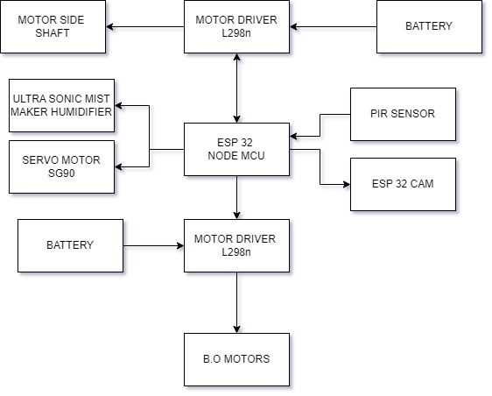

TITLE OF THE PROJECT – **SANITRON**

**What inspired you to select the problem?**

In day to day life we do observe people who work in railway compartments is a huge task ,for the living in unhygenic surroundings.Also cleaning the compartments manually is a huge taskand risk. This bot is designed to clean the compartments and maintain hygiene without human involvement.

**What do you feel is the most innovative part of the problem?**

A bot is able to clean the surface with the brushes at the bottom , And also controlled and supervised by a person through camera , through PIR it detects the objects which emit some level of infrared radiation.

**SANITRON**

1.Kaushik rRam , 2.Karthik , 3.Banoth Rekha , 4.Sayeedgar Sai Hemanshu Goud , 5.Gangavaram Ananya Sai , 6. Aditi Joshi ,7.Charan Tej Reddy Yempalla,

8.Adithya Krishna S , P. Varun , Devisri Samala ,M.Pravalika .

Abstract ~ Workers in railway compartments face a variety of challenges that can affect their safety, well-being, and efficiency. These issues can be grouped into several categories, including physical, psychological, and organizational problems. Some of the common problems faced by them are sanitation and hygienic.Poor Sanitary Conditions Inadequate sanitation facilities can lead to health problems and discomfort.Lack of proper hygiene facilities can contribute to the spread of diseases.

**INTRODUCTION**

The present situation poses an extreme health threat, driven by the alarming possibility of disease transmission in crowded trains. With passenger numbers soaring, the danger intensifies exponentially. Traditional cleaning methods, reliant on human labor, are not only exhausting but also riddled with mistakes and inefficiencies. This manual approach is inadequate for ensuring thorough sanitization. Consequently, there is an urgent and undeniable necessity to innovate and implement an automated system. Such a system ensures effective sanitization of train compartments without manual interevention.

Considering the above problem, our team has come up with a solution of creating “SANITRON “a sanitization robot. This robot should be able to efficiently move through train compartments and carry out sanitization tasks effectively. We can use infrared sensors for obstacle detection. In case of a microcontroller, we can use Node

MCU. We can implement the navigation algorithm for the bot to move through the compartments efficiently. We can equip the bot with wheels for mobility, use motor drivers and algorithms for regulation of sanitizer. We can also create feedback mechanisms to adjust the speed or direction in response to the obstacles.

**I.PROBLEM STATEMENT**

The present situation poses an extreme health threat, driven by the alarming possibility of disease transmission in crowded trains. With passenger numbers soaring, the danger intensifies exponentially. Traditional cleaning methods, reliant on human labor, are not only exhausting but also riddled with mistakes and inefficiencies. This manual approach is inadequate for ensuring thorough sanitization. Consequently, there is an urgent and undeniable necessity to innovate and implement an automated system. Such a system ensures effective sanitization of train compartments without manual interevention.

**II.LITERATURE SURVEY**

We all discussed about the problem statement and put out our own ideas and changes to bring this small-scale project which can be made fast. We saw multiple videos and had many discussions on how to implement our idea in an efficient and what are the measures we need to take while doing the project.

**III.ARCHITECTURE**

# Amazon.in: Buy DOIT DEVIT V1 ESP32-WROOM-32 Development Board ESP32 ESP-32S WiFi Bluetooth Dev Module CP2102 for Arduino Online at Low Prices in India | DIYmall Reviews & Ratings

Fig.4.1.ESP 32

1.ESP 32

• The ESP 32 is a popular

microcontroller unit ideal for internet of

things (IoT) projects . It is a low cost and

low power system that integrates Wi-Fi

and bluetooth.

• It's low cost and low power

consuming properties makes it suitable

for battery powered projects.

• It integrates various components like

memory, processors, and wireless

connectivity onto a single chip

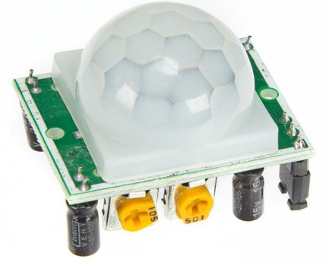

Fig.4.2.PIR Sensor

**2.PIR SENSOR**

**• A PIR sensor, or Passive Infrared sensor, is a**

**motion detector that uses infrared radiation to sense**

**movement.**

**• Detects Heat: All objects with some heat emit**

**infrared radiation, invisible to us but detectable**

**by the sensor.**

**• Dual Detectors: The sensor has two**

**compartments that sense this radiation.**

**• Movement Triggers: When someone moves**

**across the sensor's field of view, they disrupt the**

**infrared radiation pattern hitting the detectors.**

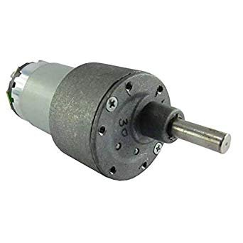**• Signal Output: This change triggers an electrical**

**signal indicating motion**

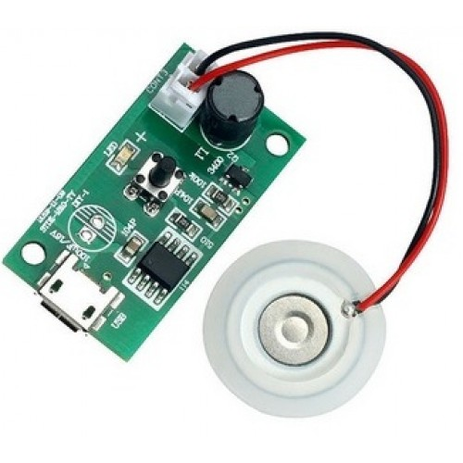

Fig.4.3.UltraSonic Mist Maker

**3.ULTRASONIC**

**MIST MAKER**

**• An ultrasonic mist maker humidifier uses**

**high-frequency sound waves (ultrasonic) to**

**create a cool mist.**

**• Ultrasonic vibrations: A metal plate**

**vibrates at ultrasonic frequencies, t**

**• Cool mist: The vibrations produce a fine**

**cool mist that gets released into the air.**

**• Humidification: This mist increases the**

**moisture level in your surroundings**

**4.SIDE SHAFT MOTORS**

• Side shaft motors are a type of electric motor where the

output shaft comes out from the side of the motor body,

Fig.4.4.Side Shaft Motors

rather than the end. This design offers a few advantages:

• Compactness: By having the shaft on the side, the

overall footprint of the motor can be smaller. This is

useful in applications where space is limited.

• Right angle output: The side shaft provides a 90-degree

angle for connecting to other components. This can

simplify the design and layout of your project.

• Versatility in mounting: The side-mounted shaft allows

for more flexibility in how you mount the motor within

your project

**5.L SHAPED BO MOTORS**

•L-shaped BO motors are a type of small, lightweight DC

geared motor ideal for hobbyist projects and robotics

applications.

•Shape: L-shaped design, meaning the motor shaft comes

out at a right angle to the body of the motor. This allows for

more flexible placement in tight spaces.

•Gearbox: They have a built-in gearbox that reduces the

motor's speed (RPM) and increases its torque (turning

force). This makes them suitable for applications requiring

slower speeds with more power.

•Voltage: Typically operate on a voltage range of 3 to 12

volts DC.

•Speed: Come in various RPM options, commonly found in

60 RPM, 150 RPM, and 300 RPM versions

Fig.4.5.Shaped Bo Motors

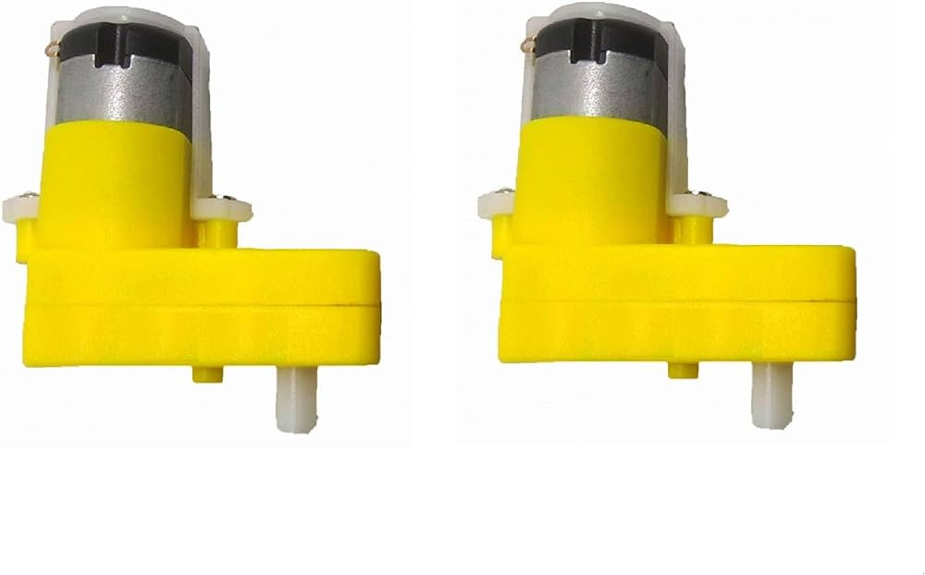

**6.MOTOR DRIVER l298n**

• The L298N is an integrated circuit (IC) that functions as a dual H-bridge motor driver. This means it can control the speed and direction of two DC motors simultaneously. It's commonly used in robotics and various control applications due to its: • DC motor control: Works with DC motors typically in the range of 5 to 35 volts and up to 2 amps. • Dual channel control: Can control two separate DC motors. • Direction control: Allows you to run the motors forward or backward. • Speed control (PWM): Can adjust the speed of the motors using pulse width modulation (PWM)

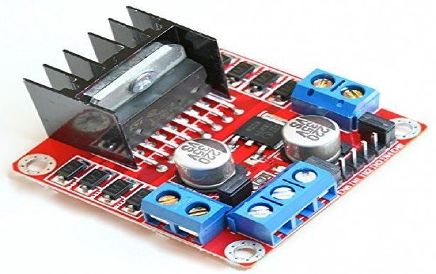

Fig.5.6.Motor driver l298n

**7.SERVO SG90**

• The SERVO SG 90, also known as the Tower Pro SG90, is a

popular micro servo motor. This means it's a small, lightweight

motor that can rotate parts with high precision.

• Tiny and Lightweight: Weighing only 9 grams, it's well-suited

for small robotics projects.

• 180-degree Rotation: It can rotate about 180 degrees (90

degrees in each direction).

• Easy to Use: It works with standard servo control signals, so

you can find plenty of code and libraries to control it.

• Good for Beginners: Because of its small size, ease of use,

and affordability, the SG90 is a popular choice for people

starting out with robotics projects

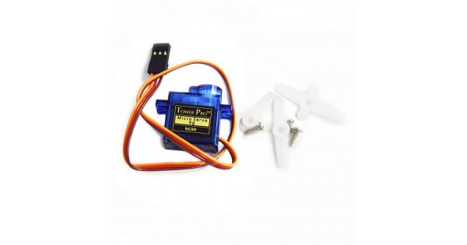

Fig.4.7.Servo Motor SG90

**8.Li-Ion battery**

• Lithium-ion batteries, or Li-ion batteries for short,

are the rechargeable batteries you likely use in most of

your everyday devices. They're popular for a reason:

• High energy density: They store a lot of energy in a

small space, allowing for slimmer devices. again.

• Long lifespan: They can go through hundreds of

charge cycles before needing replacement.

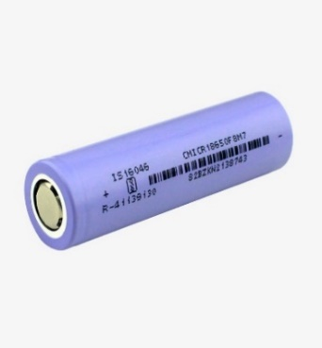

Fig.4.8.Li-ion battery

**9.ESP 32 CAM**

• The ESP32-CAM builds on the ESP32 microcontroller by adding a camera module. Here's a simplified explanation:

• Base: ESP32 microcontroller - Same processing power, WiFi, and Bluetooth as the ESP32.

• Extra: A camera module, typically the OV2640, allowing you to capture images and videos.

• Applications: Perfect for IoT projects that involve vision, such as: 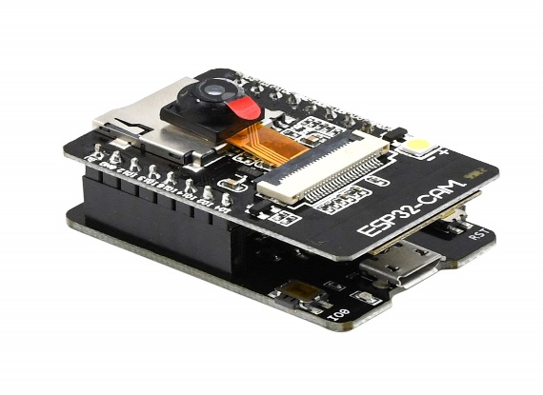

• Wireless monitoring: Keeping an eye on a remote location

. • Face recognition: Unlocking doors or identifying people

. • Image capture and upload: Taking pictures andsending them wirelessly.

**10.RACK AND PINION GEAR**

• A rack and pinion is a simple mechanism that converts rotary motion into linear motion (and vice versa). It has two key parts:

• Rack: A straight bar with teeth along one edge. Imagine a long, skinny gear laid flat.

• Pinion: A circular gear that meshes with the teeth on the rack.

• When you rotate the pinion gear, the rack moves in a straight line, as if it's being pushed or pulled. Conversely, if you move the rack back and forth, the pinion gear will rotate.

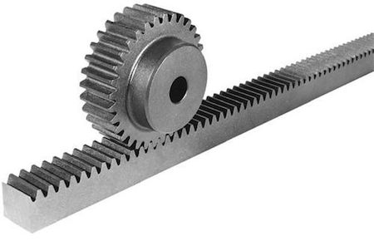

**11.BREAD BOARD**

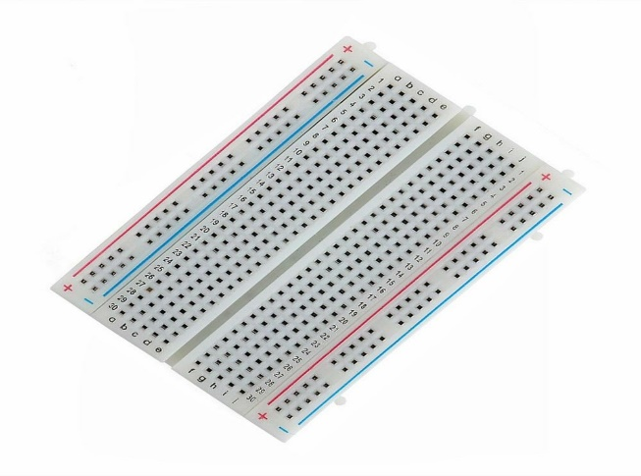

• A breadboard, also known as a solderless breadboard or protoboard, is a platform for building temporary circuits.

It's like a workbench for electronics. Here's the gist:

• Reusable: Unlike some other circuit boards,

you don't need to solder components onto a breadboard.

This makes it easy to swap things around and try different designs.

• Easy to use: Breadboards have holes that components can be plugged into

. They also have built-in channels that connect certain holes together,

making it easy to create circuits.

• For prototyping: Breadboards are ideal for building temporary

circuits to test out ideas before creating a more permanent design.

**IV.SOFTWARE REQUIREMENTS**

1. **Arduino IDE**: Arduino is an open-source hardware and software company, project, and user community that designs and manufactures single-board microcontrollers and microcontroller kits for building digital devices.

  **b) Blynk**: Blynk is a software company that project infrastructure for the Internet of Things. In 2014 Blynk pioneered the no-code approach to IoT app building and gained global popularity for its mobile app editor.



c) Fusion 360:Fusion has built-in capabilities to do 3D modeling, sheet-metal, simulation and documentation. It can manage manufacturing processes such as machining, milling, turning and additive manufacturing. It also has electronic design automation (EDA) features, such as schematic design, PCB design and component management.



d) fritzing: ritzing is essentially an [Electronic Design Automation](https://en.wikipedia.org/wiki/Electronic_design_automation) software with a low entry barrier, suited for the needs of designers and artists. It uses the metaphor of the [breadboard](https://en.wikipedia.org/wiki/Breadboard), so that it is easy to transfer your hardware sketch to the software.



**V.IMPLEMENTATION AND WORKING**

1. Initially the bot which is made through the idea is placed on the to railway compartments
2. Then if the supply is connected the bot start working.
3. The cam which is attached to the body will act as a monitoring system to the person using the bot.
4. So that the railway compartment can be cleaned and monitored

**VI.CAD**

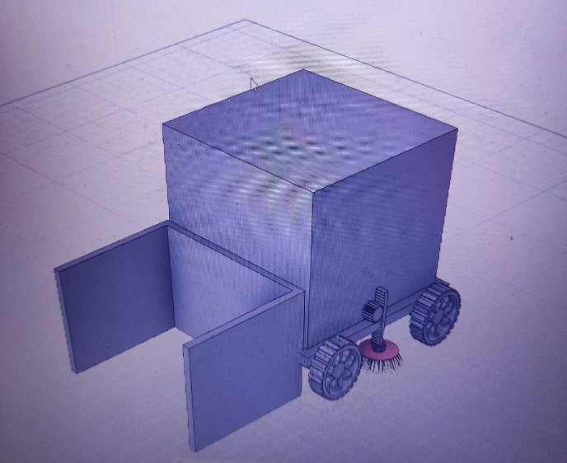

**VII.BLOCK DIAGRAM**

**IX.CIRCUIT DIAGRAM**

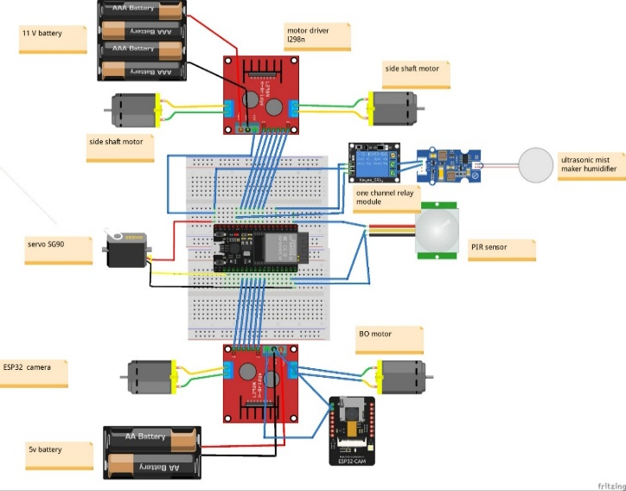

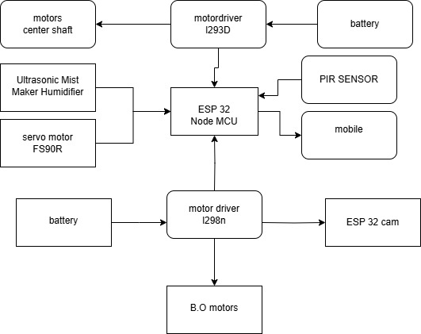**IX.RESULT**

From the project we can conclude that the project monitors the compartments to be cleaned in a certain time without human involvement .it also performs tasks like detecting infrared rays ,sanitizing,wastage collecting,. These bot can be monitored by owner through mobile application.

**X.FUTURE**

**ADVANCEMENTS**

i.Can make it autonomous bot

ii. Can add more sanitization features

iii. Can expand coverage of area to perform the task

**XI.REFERENCES**

<https://www.researchgate.net/publication/316700586_Auomated_cleaning_bot_for_Wash_rooms_and_Railway_Compartments>

**XII.SOURCE CODE**

#define BLYNK_TEMPLATE_ID "TMPL3DMdU3XEB"

#define BLYNK_TEMPLATE_NAME "xyz"

#define BLYNK_AUTH_TOKEN "9jUlkqvIyOlSJ6Qpv0g7mSdD0ELmLTkV"

#define BLYNK_PRINT Serial

#include <ESP32Servo.h>

#include <BlynkSimpleEsp32.h>

//Movement

const int motor1A = 21; // IN1

const int motor1B = 19; // IN2

const int enA = 26; // ENA

const int motor2A = 22; // IN3

const int motor2B = 23; // IN4

const int enB = 32; //ENB

// BO motor

const int motor3A = 5; // IN1

const int motor3B = 18; // IN2

const int en2A = 19; // ENA

const int servoPin1 = 33;

const int servoPin2 = 25;

const int pirPin = 12; // PIR sensor output pin

//Relay

const int relayPin = 13; // Relay pin

Servo myservo1; //Servo 1Servo myservo2; //

void setup() {

Serial.begin(115200); // Initialize serial communication

Blynk.begin(BLYNK_AUTH_TOKEN, "Error","idontknow");

//Movement

pinMode(motor1A, OUTPUT);

pinMode(motor1B, OUTPUT);

pinMode(motor2A, OUTPUT);

pinMode(motor2B, OUTPUT);

pinMode(enA, OUTPUT);

pinMode(enB, OUTPUT);

//Extension and Spinning

pinMode(motor3A, OUTPUT);

pinMode(motor3B, OUTPUT);

pinMode(en2A, OUTPUT);

//REaly

pinMode(relayPin, OUTPUT);

// Attach the servo

myservo1.attach(servoPin1);

myservo2.attach(servoPin2);

// Set the PIR sensor pin as INPUT

pinMode(pirPin, INPUT);

Serial.println("PIR Sensor Test");

delay(2000); // Give the sensor time to calibrate

}

BLYNK_WRITE(V0) { //Forward Button

int value = param.asInt();

if (value == 1) {

Serial.println("Switch on V0 is ON");

forward();

} else {

Serial.println("Switch on V0 is OFF");

stopMotorsDrive();

}

}

BLYNK_WRITE(V1) { //Forward Button

int value = param.asInt();

if (value == 1) {

Serial.println("Switch on V1 is ON");

backward();

} else {

Serial.println("Switch on V1 is OFF");

stopMotorsDrive();

}

}

BLYNK_WRITE(V2) { //Forward Button

int value = param.asInt();

if (value == 1) {

Serial.println("Switch on V2 is ON");

right();

} else {

Serial.println("Switch on V2 is OFF");

stopMotorsDrive();

}

}

BLYNK_WRITE(V3) { //Forward Button

int value = param.asInt();

if (value == 1) {

Serial.println("Switch on V3 is ON");

left();

} else {

Serial.println("Switch on V3 is OFF");

stopMotorsDrive();

}

}

BLYNK_WRITE(V4) { //Extension And retraction

int value = param.asInt();

if (value == 1) {

Serial.println("Switch on V4 is ON");

extension();

spin();

} else {

Serial.println("Switch on V4 is OFF");

retraction();

stopMotorsEs();

}

}

void loop() {

Blynk.run();

// Read the PIR sensor output

int pirState = digitalRead(pirPin);

if (pirState == HIGH) {

// Motion detected

Serial.println("Motion detected!");

} else {

// No motion

Serial.println("No motion.");

}

// Delay to avoid flooding the serial monitor

delay(1000);

}

//Driving Functions

void forward() {

analogWrite(enA, 255);

analogWrite(enB, 255);

digitalWrite(motor1A, HIGH);

digitalWrite(motor1B, LOW);

digitalWrite(motor2A, HIGH);

digitalWrite(motor2B, LOW);

}

void backward() {

analogWrite(enA, 255);

analogWrite(enB, 255);

digitalWrite(motor1A, LOW);

digitalWrite(motor1B, HIGH);

digitalWrite(motor2A, LOW);

digitalWrite(motor2B, HIGH);

}

void left() {

analogWrite(enA, 255);

digitalWrite(motor1A, HIGH);

digitalWrite(motor1B, LOW);

analogWrite(enB, 255);

digitalWrite(motor2A, LOW);

digitalWrite(motor2B, HIGH);

}

void right() {

analogWrite(enA, 255);

digitalWrite(motor1A, LOW);

?/

digitalWrite(motor1B, HIGH);

analogWrite(enB, 255);

digitalWrite(motor2A, HIGH);

digitalWrite(motor2B, LOW);

}

void stopMotorsDrive() {

analogWrite(enA, 0);

analogWrite(enB, 0);

digitalWrite(motor1A, LOW);

digitalWrite(motor1B, LOW);

digitalWrite(motor2A, LOW);

digitalWrite(motor2B,LOW);

}

void extension() {

digitalWrite(relayPin, HIGH);

for (int pos = 0; pos <= 180; pos++) {

myservo1.write(pos);

myservo2.write(pos);// Tell servo to go to position in variable 'pos'

delay(15); // Wait 15ms for the servo to reach the position

}

}

void retraction() {

digitalWrite(relayPin, LOW);

for (int pos = 180; pos >= 0; pos--) {

myservo1.write(pos);

myservo2.write(pos);// Tell servo to go to position in variable 'pos'

delay(15); // Wait 15ms for the servo to reach the position

}

}

void spin(){

analogWrite(en2A, 255);

digitalWrite(motor3A, HIGH);

digitalWrite(motor3B, LOW);

}

void stopMotorsEs() {

analogWrite(en2A, 0);

digitalWrite(motor3A, LOW);

digitalWrite(motor3B, LOW);

}

**LIST OF COMPONENTS:**

|  |  |  |
| --- | --- | --- |
| COMPONENTS | QUANTITY | PRICE |
| SIDESHAFT MOTORS | 2 | 700/- |
| BO MOTORS | 2 | 100/- |
| TIRES | 4 | 400 |
| SERVO MOTORS FS90R | 2 | 220/- |
| PIR SENSOR | 1 | 150/- |
| ULTRASONIC MIST MAKER HUMIDIFIER | 2 | 600/- |
| ESP 32 | 1 | 400/- |
| BRUSHES | 2 | 250/- |
| BATTERY(12 V) | 2 | 150/- |
| JUMPER WIRES | 2 | 100/- |
| CHASES |  |  |
| PIPES |  | 80/- |
| ESP 32 CAM MODULE | 1 | 425/- |